**DAILY ONLINE ACTIVITIES SUMMARY**

|  |  |  |  |  |  |  |  |  |
| --- | --- | --- | --- | --- | --- | --- | --- | --- |
| **Date:** | **05-6-2020** | | | | | **Name:** | **Likhitha.M** | |
| **Sem & Sec** | **6th sem ‘A’** | | | | | **USN:** | **4al17cs046** | |
| **Online Test Summary** | | | | | | | | |
| **Subject** | | **1.Operations research**  **2. PAP assignment 2** | | | | | | |
| **Max. Marks** | | **30**  **30** | | **Score** | | | **30**  **13** | |
| **Certification Course Summary** | | | | | | | | |
| **Course** | **Cloud Foundations**  **gfF**  **F’o** | | | | | | | |
| **Certificate Provider** | | | **Great learning** | | **Duration** | | | **3 days** |
| **Coding Challenges** | | | | | | | | |
| **Problem Statement:** Python program to square each odd number in the list  1. Write a Java program to implement Circular Linked List Using Array And Class | | | | | | | | |
| **Status: completed** | | | | | | | | |
| **Uploaded the report in Github** | | | | | **yes** | | | |
| **If yes Repository name** | | | | | **https://github.com/likhithaMantaral/Daily-status** | | | |
| **Uploaded the report in slack** | | | | | **yes** | | | |

Online test Details:

OR

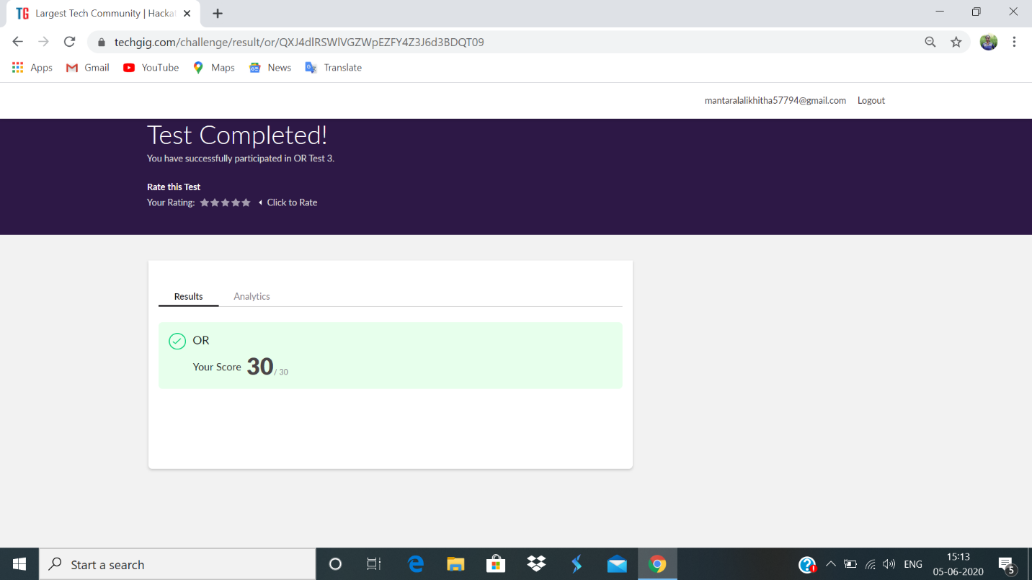

PAP

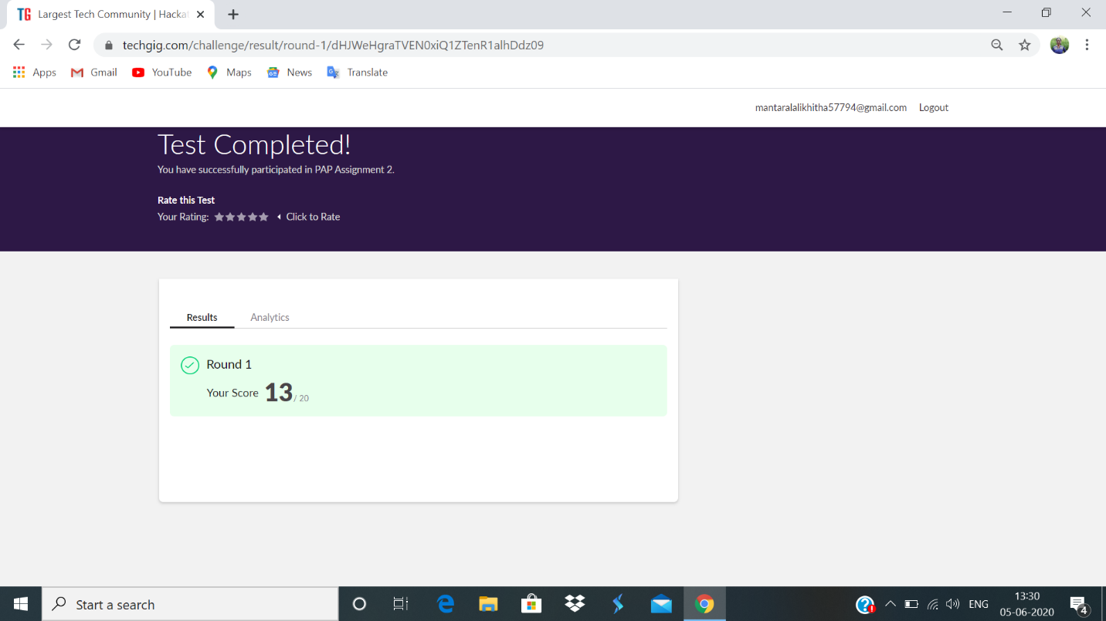

Certification Course Details:

**Summarization:**

In this we have learnt about different sets of services like, Infrastructure as a service, platform as a service. Iaas- key aspects:

1. Enterprise Infrastructure
2. Cloud hosting
3. Virtual data centers
4. Scalability
5. No investment in hardware etc.

Paas- key aspects:

1. Managed service, Foundation, APIs
2. Managed runtime, no need to start, stop
3. Auto scalability etc.

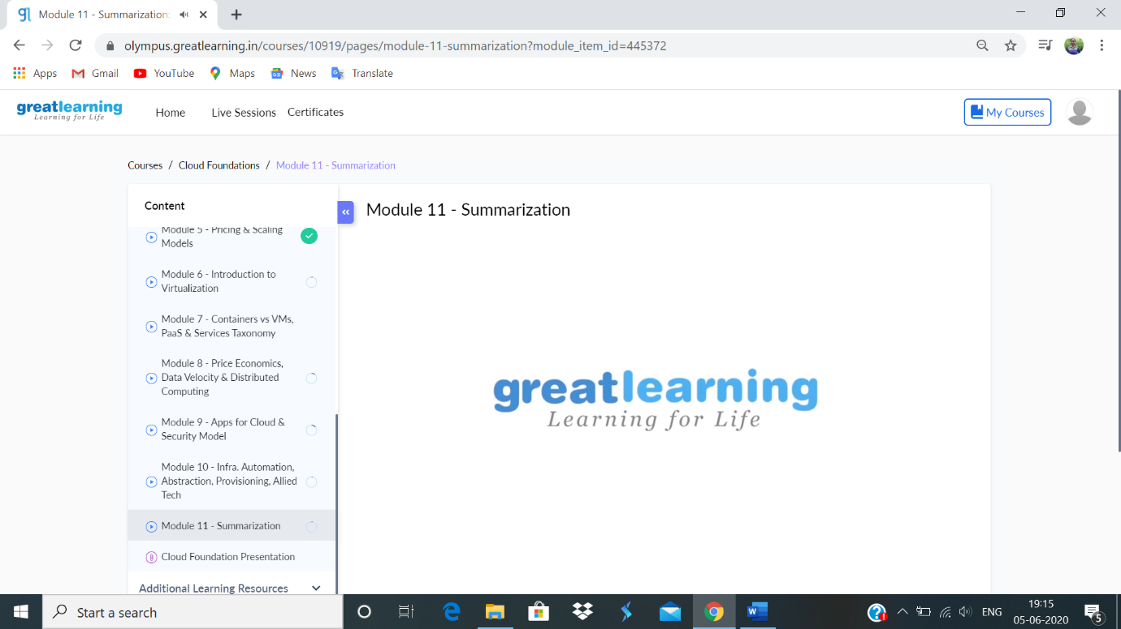

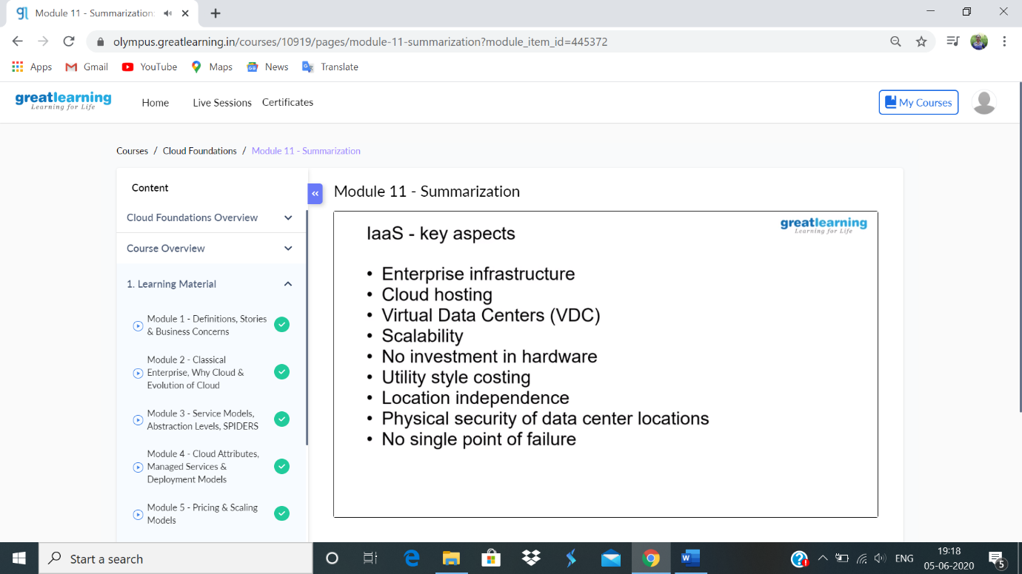

**Coding challenge:**

**1.**

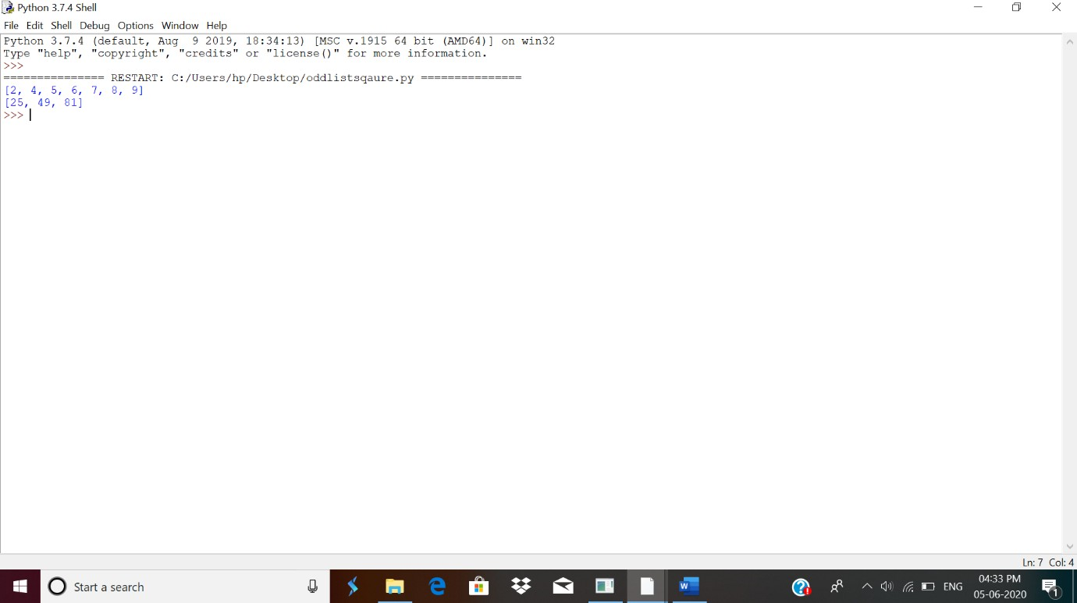

2.

